**Modeling & Forecasting**

**Consumer Confidence Index**

Yip Nam Kim

Jonathan Kizer

Arshiya Sabzevari

The University of Texas at Austin

May 2018

## Table of Contents

**Table of Contents** **1**

**Executive Summary** **2**

Analysis 2

Findings 2

**Consumer Confidence Index & Elections** **3**

**Consumer Confidence Index: 1960 - Present** **4**

**Modeling the Consumer Confidence Index** **5**

**ARIMA Model** **6**

**ARMA-GARCH Model** **7**

**Forecasting CCI with ARMA-GARCH Model** **9**

**Conclusion** **10**

**Appendix A: ARIMA Model Plots** **11**

**Appendix B: ARMA-GARCH Model Plots** **13**

**Appendix C: Project Output** **16**

## Executive Summary

### **Analysis**

This report includes an analysis and forecast of the Consumer Confidence Index in the United States from January, 1960 to February, 2018, in order to determine whether or not the Index will remain above 100 for the November, 2018 midterm elections. When Consumer Confidence is above 100, political scientists have observed that the incumbent political party typically stays in power.

### **Findings**

This report’s findings, created through the use of an ARMA-GARCH model, indicate that the Consumer Confidence Index will almost certainly remain above 100 in November, 2019. Therefore, this indicator would suggest that the Republican Party is likely to continue to hold its electoral advantage during the midterm elections.

## Consumer Confidence Index & Elections

The Consumer Confidence Index is described by the Organisation for Economic Co-operation and Development as a reflection of a household’s plans for future major purchases, as well as their current and immediate future economic situation. Opinions are collected from survey respondents; these answers are then compared to a “normal” state, with the difference between positive and negative statements providing a qualitative index on economic conditions.[1]

Beyond this, the Consumer Confidence Index in the United States has been positively correlated to the odds that an incumbent retains his or her seat in elected office.[2] Generally, the higher the elected office, the more this effect is seen. This has lead political scientists and journalists to develop a rule of thumb that a President up for reelection is very likely to win if the Consumer Confidence Index in the United States is above 100.

While the trend is not quite as pronounced for predicting United States Senate and House elections, the general rule is still useful for beginning to forecast future election results. While other macroeconomic and social trends have a large impact on the outcome of these more local elections, the general sentiment of voters towards the economy sets a decent baseline for electoral expectations.

Therefore, in addition to attempting to build a model that sufficiently explains the in-sample data and trends, this report also aims to project nine months into the future, to the upcoming November elections, in order to predict whether or not the Consumer Confidence Index will still be above this 100 threshold that seems to be influential for elections.

Modeling, and therefore predicting, Consumer Confidence is difficult. There are many factors that influence the index, including social, political, and financial trends. Additionally, it is difficult to gauge which of these types of factors typically matters most to consumers. In some cases, Presidential elections seem to swing the Consumer Confidence Index one way or another, even as other financial metrics remain relatively stable from one President to the next. At other times, it is clear that financial indicators like the stock market are heavily influential, such as during the economic crisis of 2008, when the Consumer Confidence Index fell to 96.9.

## Consumer Confidence Index: 1960 - Present

The image to the left shows Consumer Confidence Index from January, 1960 to February, 2018. While the actual variation in US Consumer Confidence Index is small -- all values are between 96 and 103 -- there appears to be large discrepancies in correlation structure and variation over time.

This points towards the dataset being non-stationary. There also appears to be a large amount of difference in variation; there are periods where the Consumer Confidence Index is very volatile, dropping or rising sharply month to month. At other times, the Index is relatively stable, staying within a small upper and lower range for possibly years. While the data appears to be heteroskedastic, there is also a minute amount of seasonality, which is taken into account with the stl() R function. The seasonality was so small as to be essentially meaningless, and so the dataset was analyzed without it.

## Modeling the Consumer Confidence Index

Various methods were used to attempt to model the Consumer Confidence Index. The full printout of every model tested -- a total of five -- may be found in Appendix C: Project Output, while the following three models will be covered in-depth in this report:

1. ARIMA Model
2. ARMA-GARCH Model

The ARIMA model (created using the auto.Arima() function) offered a result that initially appeared useful, but upon further examination failed to have Normally-distributed errors. Because of this, the model was useless for forecasting purposes, and proved that a more general framework was needed to take into account all of the trends within the Consumer Confidence Index dataset.

From that conclusion, an ARMA-GARCH model was fitted to the data, and ultimately provided the best results as it took into account the heteroskedastic nature of the dataset.

## ARIMA Model

ARIMA(3,1,2)

Coefficients:

ar1 ar2 ar3 ma1 ma2

0.1847 0.4349 -0.4429 1.3208 0.4222

s.e. 0.0853 0.0947 0.0621 0.0841 0.0473

sigma^2 estimated as 0.008244: log likelihood=685.09

AIC=-1358.18 AICc=-1358.06 BIC=-1330.9

The results of the auto.arima() function was an ARIMA(3, 1, 2) model. This model results in a standard deviation of: 0.091.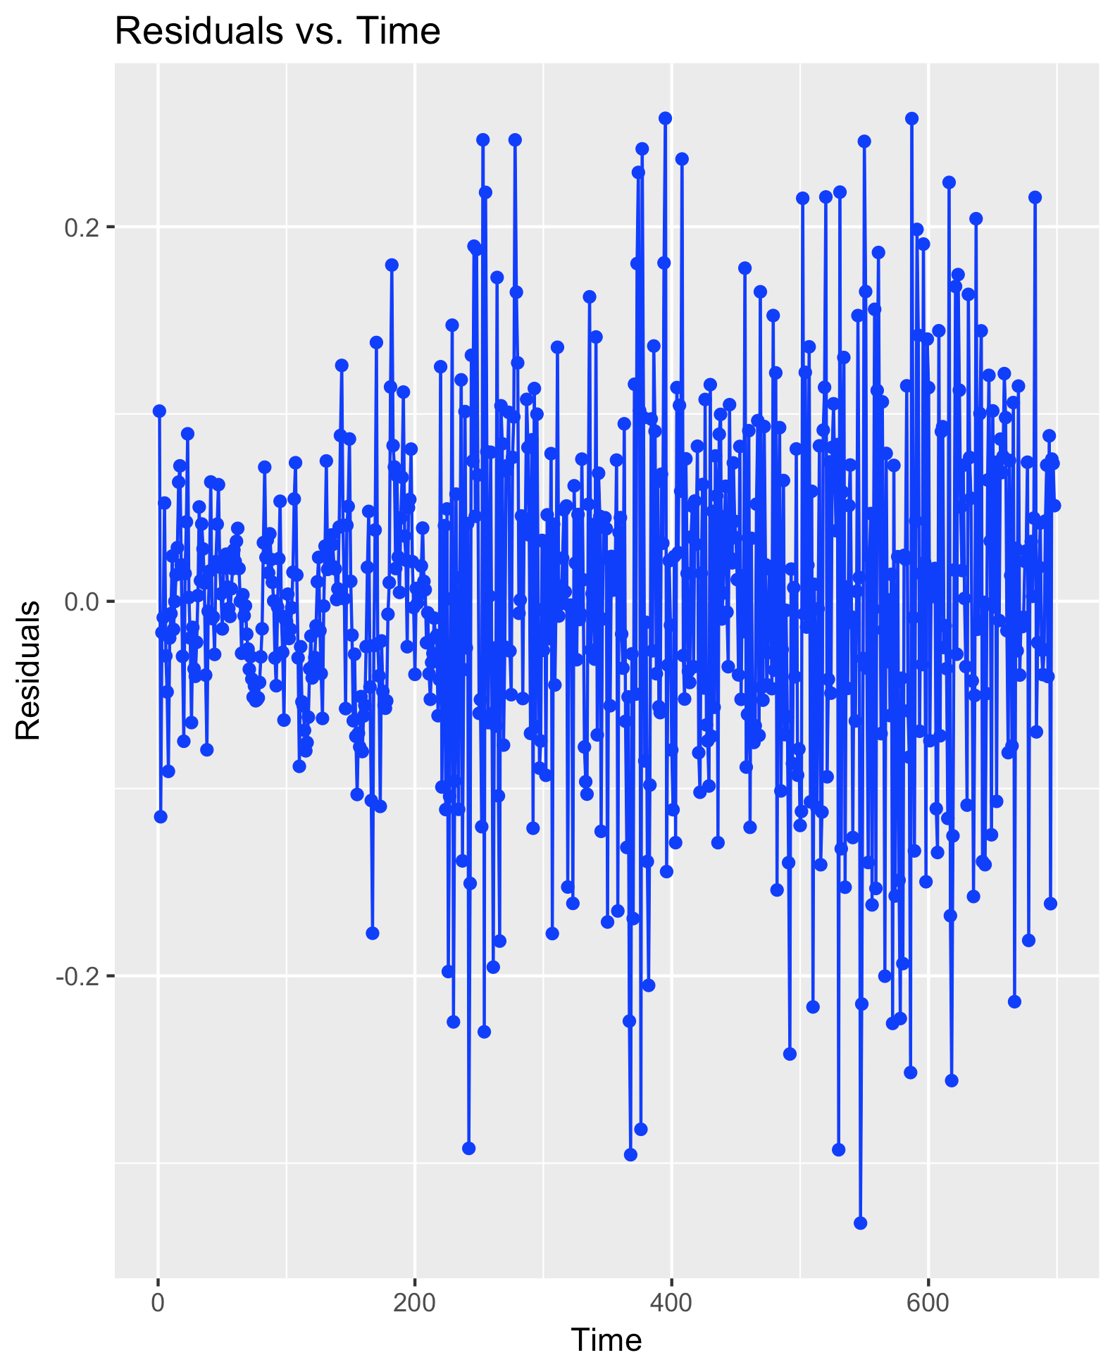

Graphing the results of this model and the actual Consumer Confidence Index appears promising (Appendix B, Figure I). The model seems to track well with the trends within the actual data.

Additionally, the ACF and PACF (Appendix B, Figures II & III) appear to show that the data is uncorrelated; the model therefore does a good job of extracting data and underlying trends within the Index dataset.

Issues begin to arise when observing the residuals from this model (see above graph). There appears to still be trends within the residuals. Upon further work and after applying the Anderson-Darling test and creating a QQPlot (Appendix B, Figure IV) of the errors, it becomes clear that the errors are not Normally distributed. Therefore, despite a good AIC and low sigma value, one of the underlying assumptions of the model is violated, and it is therefore useless for creating meaningful forecasts.

This supports the original observation that the data may not be heteroskedastic, and that therefore an ARMA model with GARCH errors is almost certainly necessary.

## ARMA-GARCH Model

With each model displaying the same violation of Normality to a significant degree, it became clear that the Consumer Confidence Index required the use of a model that could track changing errors over time. Additionally, the correct model still had to incorporate trend and level throughout the large Index dataset.

The final model tested was therefore an ARMA-GARCH model. This model made use of the input parameters previously found with the auto.arima() command for the *p=3* and *d=2* components. The GARCH component was set to (1, 1), after running various iterations and choosing the result with the lowest AIC value, as well as inspecting the ACF and PACF plots. This model was created using the rugarch R package, which allows for the simultaneous creation of a model that incorporates an ARMA model for the mean, and a GARCH model for the variance.[3]

*---------------------------------*

* GARCH Model Fit *

*---------------------------------*

Conditional Variance Dynamics

-----------------------------------

GARCH Model : sGARCH(1,1)

Mean Model : ARFIMA(3,0,2)

Distribution : norm

Optimal Parameters

------------------------------------

Estimate Std. Error t value Pr(>|t|)

mu 101.215054 0.059340 1705.6772 0.0000

ar1 1.962917 0.009355 209.8334 0.0000

ar2 -1.398994 0.015342 -91.1857 0.0000

ar3 0.426647 0.020589 20.7221 0.0000

ma1 0.683141 0.043430 15.7296 0.0000

ma2 0.285677 0.040023 7.1377 0.0000

omega 0.000037 0.000024 1.5726 0.1158

alpha1 0.113514 0.020929 5.4238 0.0000

beta1 0.885486 0.019457 45.5098 0.0000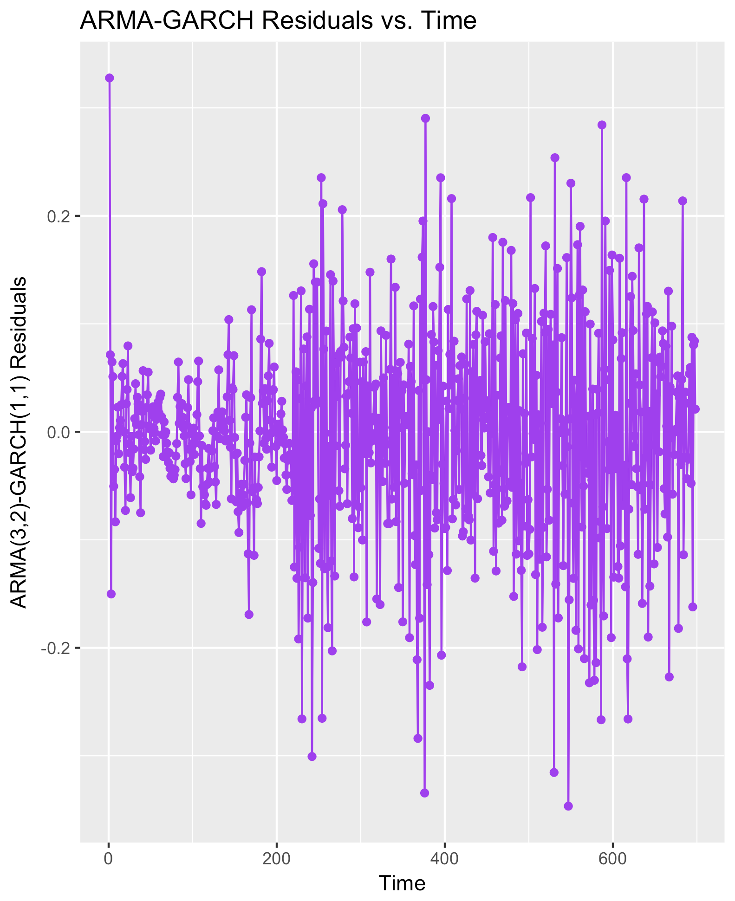

This model results in an AIC, after being multiplied by the number of data points in the Consumer Confidence Index dataset, of -1517.173. Additionally, the ACF and PACF show that the *η* and *η*2 are uncorrelated (Appendix C, Figures I & II). The residuals, plotted to the left, display fewer signs of clear trends and correlation. Finally, the Ljung-Box test of both the η and the η2 terms indicates constant variance and that the eta terms are uncorrelated.

The model may be seen compared against the original CCI data in Appendix C, Figure IV.

While the ARMA-GARCH method does seem to better explain the Index dataset than the other attempted models, there are still issues. This likely is because Consumer Confidence Index itself depends on a number of factors.

While some of the trends could be accounted for with explanatory variables, it would take a subject matter expert to identify those variables and know that they are a cause of whatever trend is seen in the Index dataset. A future report, built upon this ARMA-GARCH model, may try to account for this.

## Forecasting CCI with ARMA-GARCH Model

To answer the actual question -- whether or not the Consumer Confidence Index will remain above 100 in nine months from the last data point included in this dataset (i.e., November, 2019’s midterm elections), the ARMA-GARCH model was used.

*------------------------------------*

* GARCH Model Forecast *

*------------------------------------*

Model: sGARCH

Horizon: 9

Forecast:

Series Sigma

T+1 101.6 0.08264

T+2 101.7 0.08283

T+3 101.7 0.08301

T+4 101.7 0.08320

T+5 101.7 0.08338

T+6 101.6 0.08356

T+7 101.6 0.08374

T+8 101.6 0.08393

T+9 101.6 0.08411

Therefore, if Erikson’s *The Macro Polity* and a general rule of thumb for political scientists holds true, it is unlikely that Republicans will experience a major loss in the number of seats in the House and the Senate, since the Consumer Confidence Index will remain above 100 during the time period between now and the election. It is possible, of course, that external variables could change this forecast, or else that this election breaks the trend that Erikson described and codified.

## Conclusion

This report finds an ARMA-GARCH model to be best suited to forecast Consumer Confidence Index. This model incorporates an ARMA model to predict the mean, and a GARCH model to account for unstable variance throughout time.

While this model was able to account for both the changes in mean and the changing errors over time, further analysis could be applied to the Index dataset in the form of external variables. However, due to the wide array of possible variables that may be influential on consumer answers that ultimately create the Index -- and the issue of consumers weighting different factors higher or lower over time depending on still other variables -- an expert in the area of Consumer Confidence Index collection and creation would be required.

The ARMA-GARCH analysis and forecast finds it exceedingly unlikely that the Consumer Confidence Index will fall below 100, a threshold used by political scientists to judge whether or not a change in the dominant political party is likely, between now and the elections of November, 2019.

## Appendix A: ARIMA Model Plots

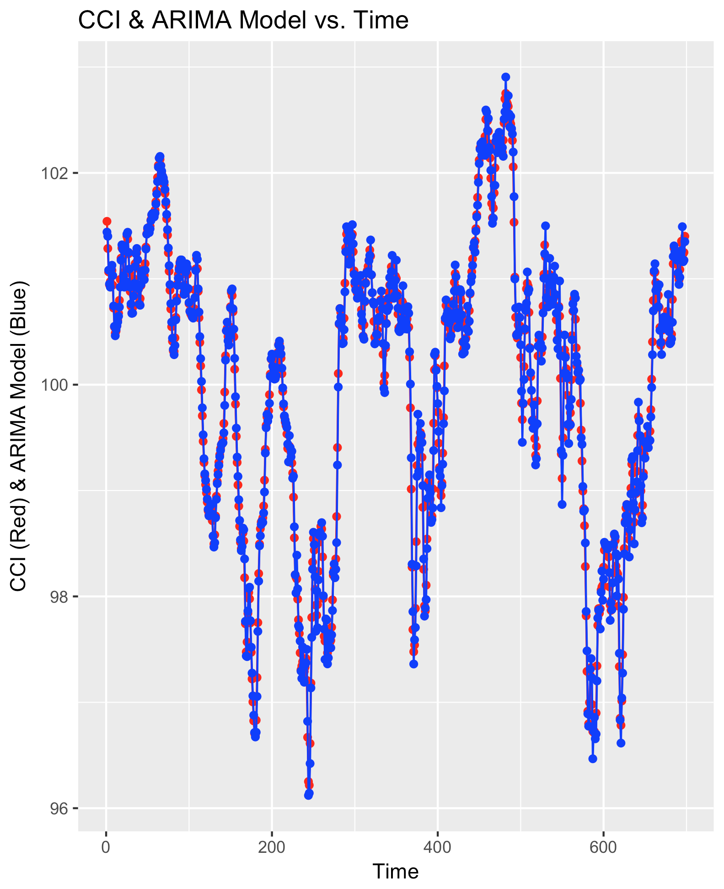

Figure I

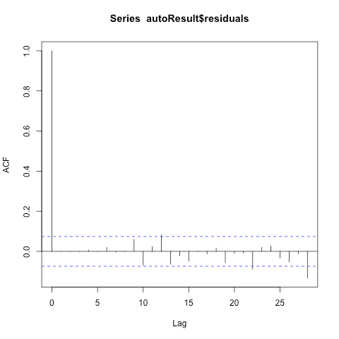

Figure B.II: ARIMA Residuals ACF

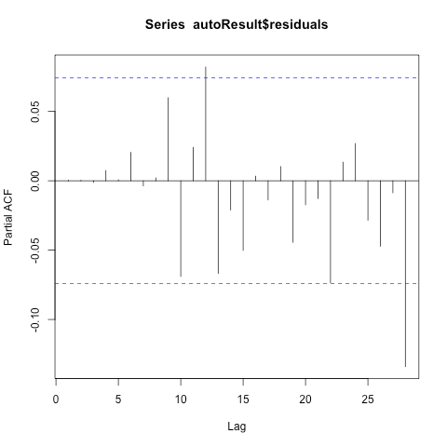

Figure III: ARIMA Residuals PACF

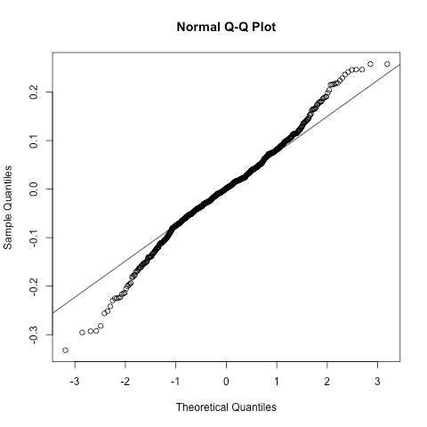

Figure IV: ARIMA Residuals QQPlot

## Appendix B: ARMA-GARCH Model Plots

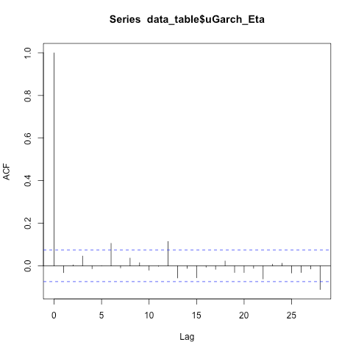

Figure I: ARMA-GARCH *η* ACF

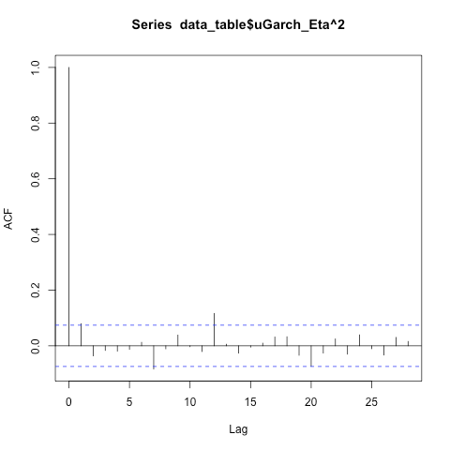

Figure 2: ARMA-GARCH *η2* ACF

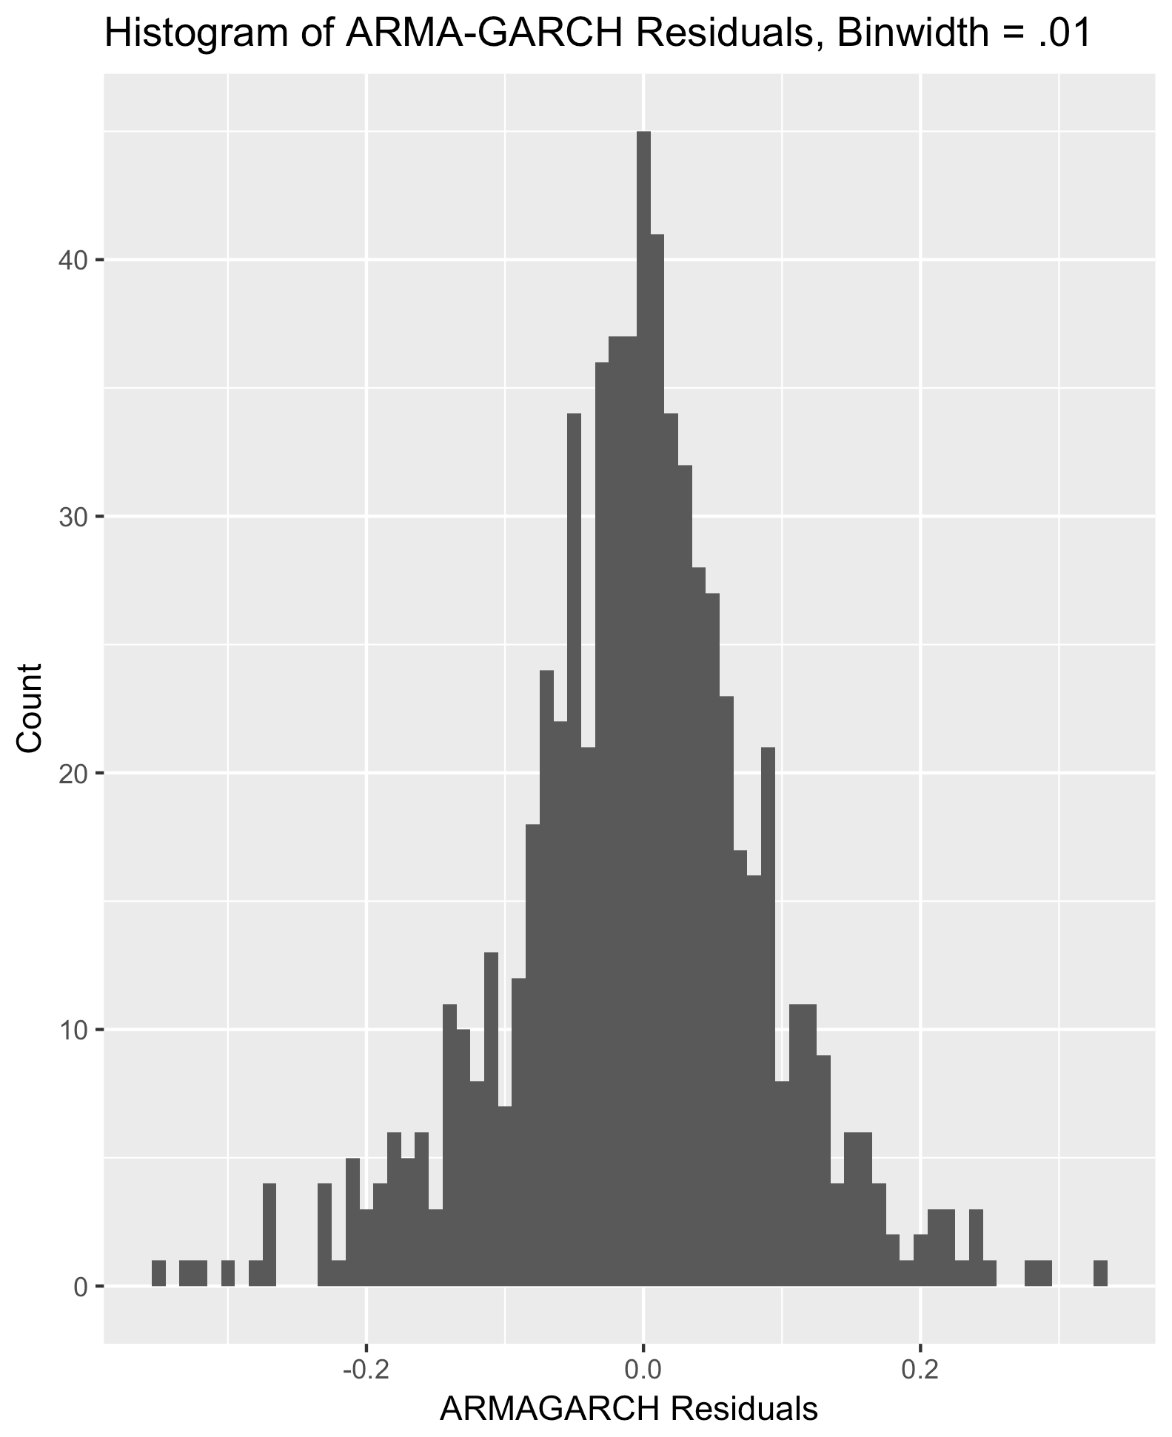

Figure III: Histogram of Residuals

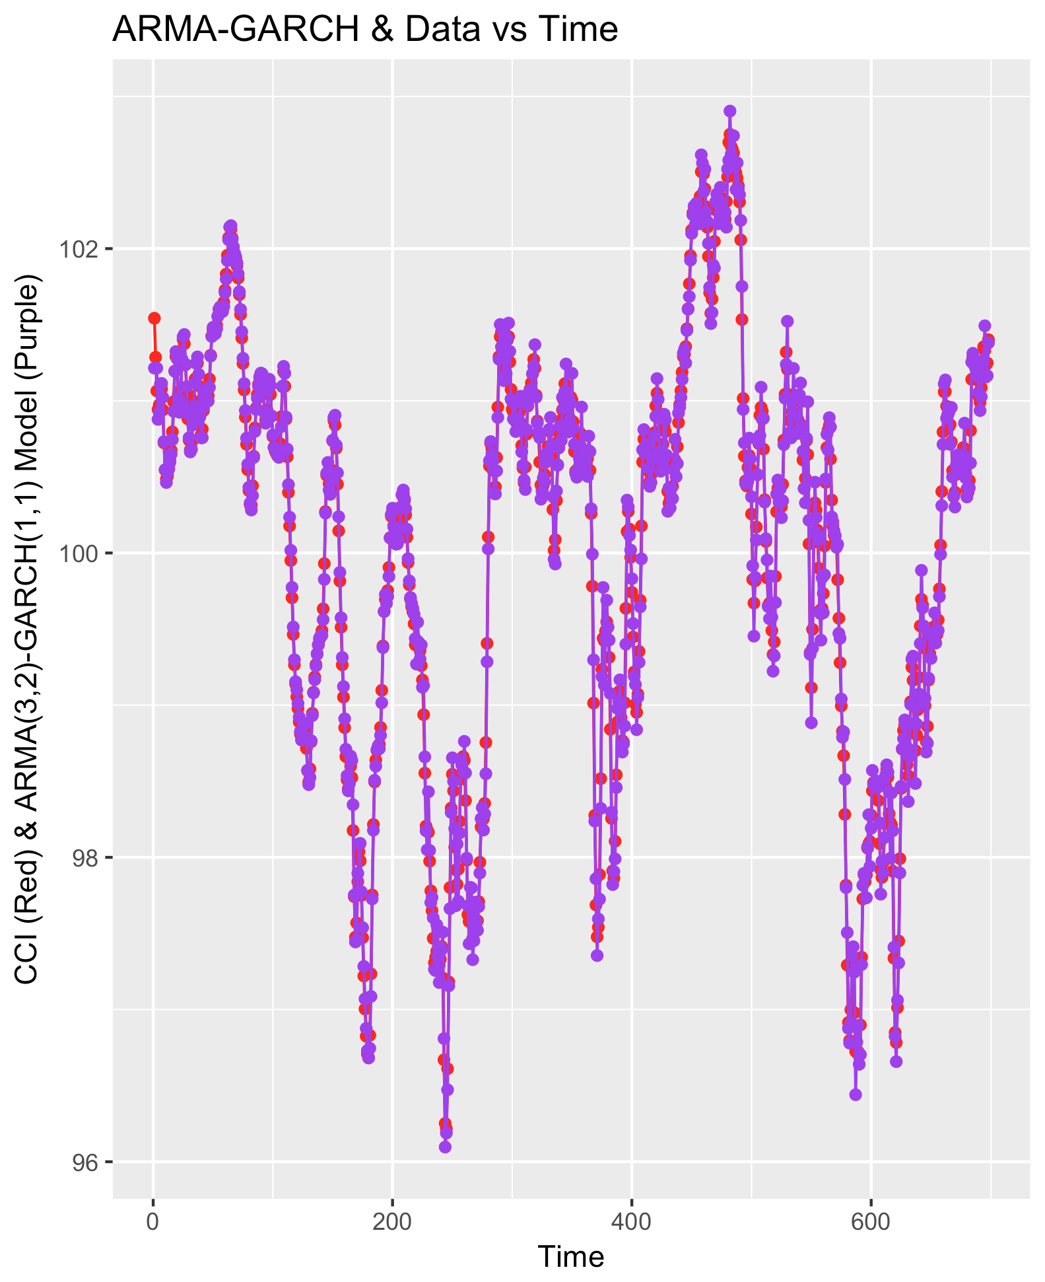

Figure IV: ARMA-GARCH Model & CCI Data vs. Time

## Appendix C: Project Output

-----------------------BEGIN ANALYSIS-----------------------

Data Table First and Last Six Columns:

Time YearMonth CCI

1 1 1960-01 101.5427

2 2 1960-02 101.2864

3 3 1960-03 101.0649

4 4 1960-04 100.9428

5 5 1960-05 100.9736

6 6 1960-06 101.0609

Time YearMonth CCI

693 693 2017-09 101.2071

694 694 2017-10 101.3554

695 695 2017-11 101.3308

696 696 2017-12 101.2372

697 697 2018-01 101.2492

698 698 2018-02 101.4019

Augmented Dickey-Fuller Test

data: ts(data_table[, 3])

Dickey-Fuller = -3.1288, Lag order = 8, p-value = 0.1005

alternative hypothesis: stationary

--------ARIMA Model Analysis--------

ARIMA(0,1,0) : -251.4833

ARIMA(0,1,0) with drift : -249.4724

ARIMA(0,1,1) : -910.1783

ARIMA(0,1,1) with drift : -908.1616

ARIMA(0,1,2) : -1266.423

ARIMA(0,1,2) with drift : -1264.401

ARIMA(0,1,3) : -1323.583

ARIMA(0,1,3) with drift : -1321.554

ARIMA(0,1,4) : -1344.371

ARIMA(0,1,4) with drift : -1342.336

ARIMA(0,1,5) : -1344.57

ARIMA(0,1,5) with drift : -1342.529

ARIMA(1,1,0) : -877.4608

ARIMA(1,1,0) with drift : -875.4441

ARIMA(1,1,1) : -1225.638

ARIMA(1,1,1) with drift : -1223.615

ARIMA(1,1,2) : -1329.168

ARIMA(1,1,2) with drift : -1327.14

ARIMA(1,1,3) : -1333.358

ARIMA(1,1,3) with drift : -1331.324

ARIMA(1,1,4) : -1343.199

ARIMA(1,1,4) with drift : -1341.158

ARIMA(2,1,0) : -1299.607

ARIMA(2,1,0) with drift : -1297.584

ARIMA(2,1,1) : -1353.973

ARIMA(2,1,1) with drift : -1351.944

ARIMA(2,1,2) : -1354.6

ARIMA(2,1,2) with drift : -1352.566

ARIMA(2,1,3) : -1353.795

ARIMA(2,1,3) with drift : -1351.754

ARIMA(3,1,0) : -1351.422

ARIMA(3,1,0) with drift : -1349.393

ARIMA(3,1,1) : -1353.867

ARIMA(3,1,1) with drift : -1351.832

ARIMA(3,1,2) : -1358.058

ARIMA(3,1,2) with drift : -1356.017

ARIMA(4,1,0) : -1354.146

ARIMA(4,1,0) with drift : -1352.111

ARIMA(4,1,1) : -1352.197

ARIMA(4,1,1) with drift : -1350.156

ARIMA(5,1,0) : -1352.283

ARIMA(5,1,0) with drift : -1350.242

Series: CCITimeSeries

ARIMA(3,1,2)

Coefficients:

ar1 ar2 ar3 ma1 ma2

0.1847 0.4349 -0.4429 1.3208 0.4222

s.e. 0.0853 0.0947 0.0621 0.0841 0.0473

sigma^2 estimated as 0.008244: log likelihood=685.09

AIC=-1358.18 AICc=-1358.06 BIC=-1330.9

Augmented Dickey-Fuller Test

data: autoResult$residuals

Dickey-Fuller = -8.0567, Lag order = 8, p-value = 0.01

alternative hypothesis: stationary

Point Forecast Lo 80 Hi 80 Lo 95 Hi 95

699 101.5753 101.4589 101.6917 101.39734 101.7533

700 101.6900 101.3761 102.0039 101.20990 102.1701

701 101.7190 101.1917 102.2462 100.91256 102.5253

702 101.6974 100.9892 102.4055 100.61438 102.7804

703 101.6552 100.8099 102.5005 100.36240 102.9480

704 101.6252 100.6802 102.5701 100.17999 103.0704

705 101.6108 100.5891 102.6326 100.04823 103.1735

706 101.6138 100.5271 102.7006 99.95182 103.2758

707 101.6214 100.4736 102.7693 99.86600 103.3769

Anderson-Darling normality test

data: autoResult$residuals

A = 2.8841, p-value = 2.957e-07

--------Holt's Model Analysis--------

Holt's method

Call:

holt(y = logCCIITS, h = 9)

Smoothing parameters:

alpha = 0.9999

beta = 0.9999

Initial states:

l = 4.6383

b = -0.028

sigma: 0.0015

AIC AICc BIC

-4459.656 -4459.569 -4436.915

Point Forecast Lo 80 Hi 80 Lo 95 Hi 95

699 4.620599 4.618625 4.622572 4.617580 4.623617

700 4.622106 4.617692 4.626519 4.615356 4.628855

701 4.623613 4.616228 4.630997 4.612319 4.634906

702 4.625120 4.614310 4.635930 4.608587 4.641652

703 4.626627 4.611990 4.641263 4.604242 4.649011

704 4.628134 4.609307 4.646961 4.599340 4.656927

705 4.629641 4.606289 4.652993 4.593927 4.665354

706 4.631148 4.602959 4.659336 4.588037 4.674258

707 4.632655 4.599336 4.665973 4.581699 4.683610

Anderson-Darling normality test

data: holtResult$residuals

A = 7.9629, p-value < 2.2e-16

--------SES Model Analysis--------

Simple exponential smoothing

Call:

ses(y = SESTS, h = 9)

Smoothing parameters:

alpha = 0.9999

Initial states:

l = 101.5423

sigma: 0.2016

AIC AICc BIC

2341.073 2341.107 2354.717

Point Forecast Lo 80 Hi 80 Lo 95 Hi 95

699 101.4019 101.1435 101.6603 101.0067 101.7970

700 101.4019 101.0365 101.7673 100.8431 101.9607

701 101.4019 100.9544 101.8494 100.7175 102.0863

702 101.4019 100.8852 101.9186 100.6116 102.1921

703 101.4019 100.8242 101.9796 100.5184 102.2854

704 101.4019 100.7691 102.0347 100.4341 102.3697

705 101.4019 100.7184 102.0854 100.3565 102.4473

706 101.4019 100.6712 102.1326 100.2843 102.5194

707 101.4019 100.6268 102.1769 100.2165 102.5872

Augmented Dickey-Fuller Test

data: SESResult$residuals

Dickey-Fuller = -8.1181, Lag order = 8, p-value = 0.01

alternative hypothesis: stationary

Anderson-Darling normality test

data: SESResult$residuals

A = 3.5122, p-value = 8.796e-09

--------GARCH Model Analysis--------

Title:

GARCH Modelling

Call:

garchFit(formula = data_table$CCI ~ garch(1, 0), data = data_table$CCI,

trace = F, include.constant = T)

Mean and Variance Equation:

data ~ garch(1, 0)

<environment: 0x112e031b8>

[data = data_table$CCI]

Conditional Distribution:

norm

Coefficient(s):

mu omega alpha1

100.640560 0.023246 0.975175

Std. Errors:

based on Hessian

Error Analysis:

Estimate Std. Error t value Pr(>|t|)

mu 1.006e+02 3.137e-02 3207.812 < 2e-16 ***

omega 2.325e-02 3.766e-03 6.173 6.69e-10 ***

alpha1 9.752e-01 6.253e-02 15.596 < 2e-16 ***

---

Signif. codes: 0 ‘***’ 0.001 ‘**’ 0.01 ‘*’ 0.05 ‘.’ 0.1 ‘ ’ 1

Log Likelihood:

-783.8057 normalized: -1.122931

Description:

Mon Apr 30 11:25:07 2018 by user:

Standardised Residuals Tests:

Statistic p-Value

Jarque-Bera Test R Chi^2 44.98769 1.702339e-10

Shapiro-Wilk Test R W 0.8868257 0

Ljung-Box Test R Q(10) 2733.066 0

Ljung-Box Test R Q(15) 3439.065 0

Ljung-Box Test R Q(20) 3943.882 0

Ljung-Box Test R^2 Q(10) 100.7589 0

Ljung-Box Test R^2 Q(15) 107.5815 4.440892e-16

Ljung-Box Test R^2 Q(20) 120.3588 2.220446e-16

LM Arch Test R TR^2 105.1672 0

Information Criterion Statistics:

AIC BIC SIC HQIC

2.254458 2.274006 2.254421 2.262015

Autocorrelations of series ‘data_table$GARCH1_eta’, by lag

0 1 2 3 4 5 6 7 8 9 10 11 12 13 14 15 16 17 18 19 20 21

1.000 0.908 0.766 0.659 0.600 0.572 0.559 0.538 0.512 0.494 0.490 0.488 0.473 0.449 0.417 0.391 0.378 0.378 0.386 0.379 0.352 0.341

22 23 24 25 26 27 28

0.348 0.364 0.372 0.359 0.330 0.300 0.283

--------ARMA-GARCH Model Analysis--------

*---------------------------------*

* GARCH Model Fit *

*---------------------------------*

Conditional Variance Dynamics

-----------------------------------

GARCH Model : sGARCH(1,1)

Mean Model : ARFIMA(3,0,2)

Distribution : norm

Optimal Parameters

------------------------------------

Estimate Std. Error t value Pr(>|t|)

mu 101.215054 0.059340 1705.6772 0.0000

ar1 1.962917 0.009355 209.8334 0.0000

ar2 -1.398994 0.015342 -91.1857 0.0000

ar3 0.426647 0.020589 20.7221 0.0000

ma1 0.683141 0.043430 15.7296 0.0000

ma2 0.285677 0.040023 7.1377 0.0000

omega 0.000037 0.000024 1.5726 0.1158

alpha1 0.113514 0.020929 5.4238 0.0000

beta1 0.885486 0.019457 45.5098 0.0000

Robust Standard Errors:

Estimate Std. Error t value Pr(>|t|)

mu 101.215054 0.109387 925.2927 0.000000

ar1 1.962917 0.012191 161.0077 0.000000

ar2 -1.398994 0.019261 -72.6319 0.000000

ar3 0.426647 0.027800 15.3468 0.000000

ma1 0.683141 0.079303 8.6143 0.000000

ma2 0.285677 0.066655 4.2859 0.000018

omega 0.000037 0.000030 1.2448 0.213203

alpha1 0.113514 0.026285 4.3186 0.000016

beta1 0.885486 0.025028 35.3804 0.000000

LogLikelihood : 767.5859

Information Criteria

------------------------------------

Akaike -2.1736

Bayes -2.1150

Shibata -2.1739

Hannan-Quinn -2.1509

Weighted Ljung-Box Test on Standardized Residuals

------------------------------------

statistic p-value

Lag[1] 0.7254 3.944e-01

Lag[2*(p+q)+(p+q)-1][14] 10.1811 2.379e-05

Lag[4*(p+q)+(p+q)-1][24] 17.5235 3.936e-02

d.o.f=5

H0 : No serial correlation

Weighted Ljung-Box Test on Standardized Squared Residuals

------------------------------------

statistic p-value

Lag[1] 4.443 0.03505

Lag[2*(p+q)+(p+q)-1][5] 5.425 0.12247

Lag[4*(p+q)+(p+q)-1][9] 7.487 0.16171

d.o.f=2

Weighted ARCH LM Tests

------------------------------------

Statistic Shape Scale P-Value

ARCH Lag[3] 0.1946 0.500 2.000 0.6591

ARCH Lag[5] 0.4709 1.440 1.667 0.8922

ARCH Lag[7] 2.6542 2.315 1.543 0.5811

Nyblom stability test

------------------------------------

Joint Statistic: 8.8357

Individual Statistics:

mu 0.006757

ar1 0.072521

ar2 0.025178

ar3 0.026779

ma1 1.094480

ma2 1.624457

omega 0.507932

alpha1 0.199209

beta1 0.351447

Asymptotic Critical Values (10% 5% 1%)

Joint Statistic: 2.1 2.32 2.82

Individual Statistic: 0.35 0.47 0.75

Sign Bias Test

------------------------------------

t-value prob sig

Sign Bias 0.3059 0.7598

Negative Sign Bias 0.3229 0.7468

Positive Sign Bias 1.1654 0.2443

Joint Effect 1.5163 0.6785

Adjusted Pearson Goodness-of-Fit Test:

------------------------------------

group statistic p-value(g-1)

1 20 13.06 0.8355

2 30 37.47 0.1345

3 40 47.67 0.1607

4 50 52.86 0.3274

Elapsed time : 0.3263631

Box-Ljung test

data: data_table$uGarch_Eta

X-squared = 11.669, df = 10, p-value = 0.3078

Box-Ljung test

data: data_table$uGarch_EtaSq

X-squared = 12.147, df = 10, p-value = 0.2753

*------------------------------------*

* GARCH Model Forecast *

*------------------------------------*

Model: sGARCH

Horizon: 9

Roll Steps: 0

Out of Sample: 0

0-roll forecast [T0=1971-11-30]:

Series Sigma

T+1 101.6 0.08264

T+2 101.7 0.08283

T+3 101.7 0.08301

T+4 101.7 0.08320

T+5 101.7 0.08338

T+6 101.6 0.08356

T+7 101.6 0.08374

T+8 101.6 0.08393

T+9 101.6 0.08411

Corrected AIC (AIC * n):

-1517.173

-----------------------END ANALYSIS-----------------------

1. OECD.org Consumer confidence index (CCI). (n.d.). Retrieved from http://www.oecd.org/
2. Erikson, R. S., MacKuen, M., & Stimson, J. A. (2006). The Macro Polity. New York: Cambridge University Press.
3. Ghalanos, A. (2018, January 28). Rugarch. Retrieved from http://www.unstarched.net/r/rugarch/